Board meeting 5, Thursday, 13th August
Via Zoom

Attendees
Shaun England, Too Good To Waste (SE)
Adrian Emmett, The Lion (AE)
Rhian Derrick, Devonalds (RD)
Daryl Hodges, Coop (DH)
Darren Notley, RCTCBC

Peter Williams, The means (PW)
Mandy Jenkins, The means (MJ)

Apologies
Allan Jones, Maindy Heating (AJ)
Laura Thomas (LT), RCTCBC

Item | Detail | Action
1.0 | Welcome and apologies  SE opened the meeting and welcomed all attendees. Apologies given as above.  SE reiterated to the board the importance of attending board meetings and all to make an effort to discover why those members who aren’t present aren’t attending.
2.0 | Conflict of interest  AE explained to the board that he had become a director for the Near Me Now ecommerce platform which would be applying to the Pen-Y-Cymmoedd Fund. He was asking for a letter of support from Love Treorchy for the application.  The board discussed this and agreed that a letter could be sent. AE to send SE information on the project after which SE to draft the letter of support. | AE: To send SE some information on the Near Me Now initiative and SE to draft a letter of support from Love Treorchy
3.0 | Minutes of the last meeting and matters arising  - Confirmation of minutes  Those present confirmed that the minutes were an accurate account of discussions.  - Matters arising  - Letter to accompany levy bills  MJ had drafted the letter which was approved and sent to the Ratings Department to be despatched with the bills.  - Stay Well At Work Team case studies  DN had spoken to the team about providing these.  - Website  Ongoing as AE had been unable to speak to LW. AE to speak directly to Leon instead.  - Marketing / social media meeting  MJ and AE had met with Jade Evans to discuss and agreed that at the moment due to there being no events there was not that much that could be posted.  - Director registration  All directors could now be registered as a new access code had been received from Companies House. | AE: To speak to Leon at High Street Media about the website
4.0 | Programme  - Application to Pen-Y-Cymoedd  PW gave an update on what had happened with the application since the last meeting. The board of Our Aberdare BID had decided against proceeding with the joint application. PW had revised the proposal and resubmitted one on behalf of Love Treorchy only for £174,750. SE, RD and PW attended an interview with PYC officers. The application was currently being considered by PYC.  - PPE pack  AE told the board that the Covid Ready packs had been well received and that feedback from businesses was good.  - Transforming Towns funding  DN told the board about the funding which had been made available by Welsh Government. The local authority was still having internal discussions around how it could best be used.
5.0 | Marketing  - Social media  See 3.2.4 above.  - e-newsletter  MJ shared the following information with the board:  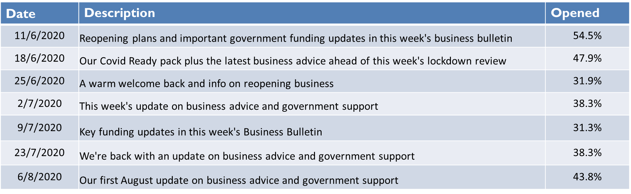  17 newsletters, 48 subscribers.
6.0 | Finance  - Income Report  - Update on levy collection from RCTCBC  Bills yet to be sent out.  - Expenditure Report - Draft Annual Budget  PW to update the budget in line with the updated application to PYC. | PW: To update the budget
7.0 | AOB  DN and PW told the board about the RCT towns resilience project currently being undertaken by The means. The board agree that a link to the online survey could be included in the e-newsletter and AE agreed to cascade to the Chamber of Trade contacts.

